**CP Club 365 Days Challenge**

**Programming language – C++**

**Problem Statement**

<https://practice.geeksforgeeks.org/problems/95423710beef46bd66f8dbb48c510b2c320dab05/1>

Git :- <https://github.com/Vedantbharad2603/CP_club_365_Days>

**Your Code**:

class Solution{

    public:

    void connect(Node *root)

    {

        // Code Here

        queue<Node*> q;

        q.push(root);

        while(!q.empty()){

            Node* temp = NULL;

            int len = q.size();

            while(len--){

                Node* temp2 = q.front();

                q.pop();

                if(temp != NULL)

                {

                    temp->nextRight = temp2;

                }

                temp = temp2;

                if(temp2->left){

                    q.push(temp2->left);

                }

                if(temp2->right){

                    q.push(temp2->right);

                }

            }

            temp->nextRight = NULL;

        }

    }

};

**Output (Screen Shot)**:

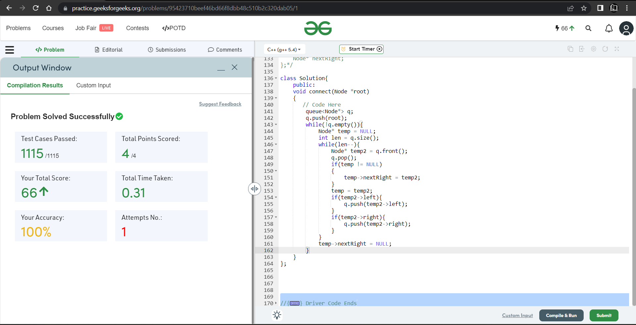

**Understanding about problem:**

* In this task there is a binary tree and I need to connect the nodes that are at the same level. With one pointer named “nextRight”.
* The pointer “nextRight” is already given but with garbage values I need to set right side of node with current node.

Note: If you can't understand the problem, feel free to contact us and we'll help you. Please don't copy and paste from anywhere.

ALL THE BEST

Team CP Club